# Screenshots showing Acadgild VM is installed properly:

# 

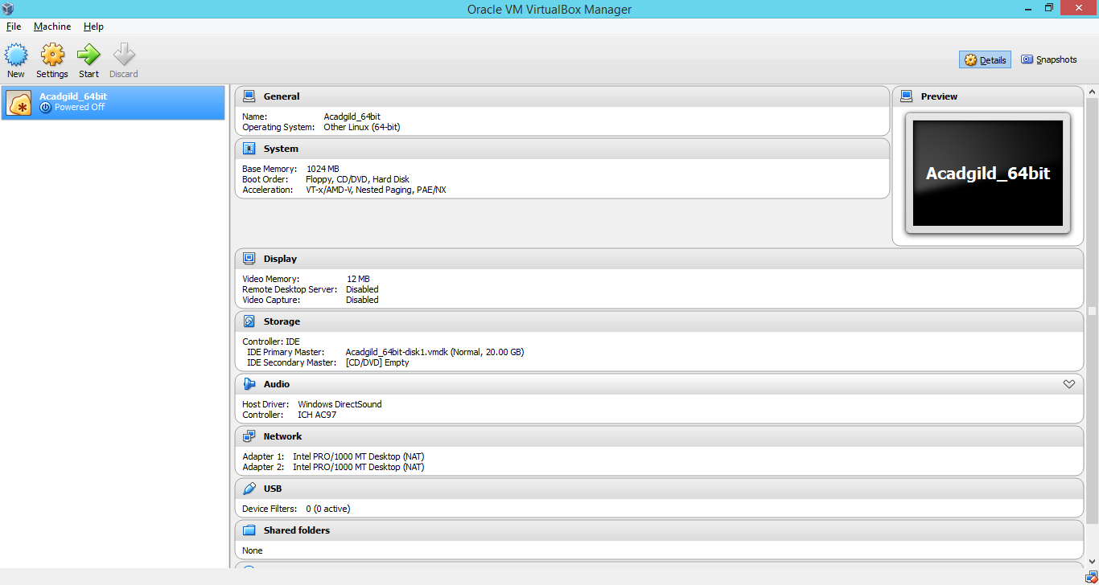

Below is the screenshot of ACADGILD VM’s Desktop:

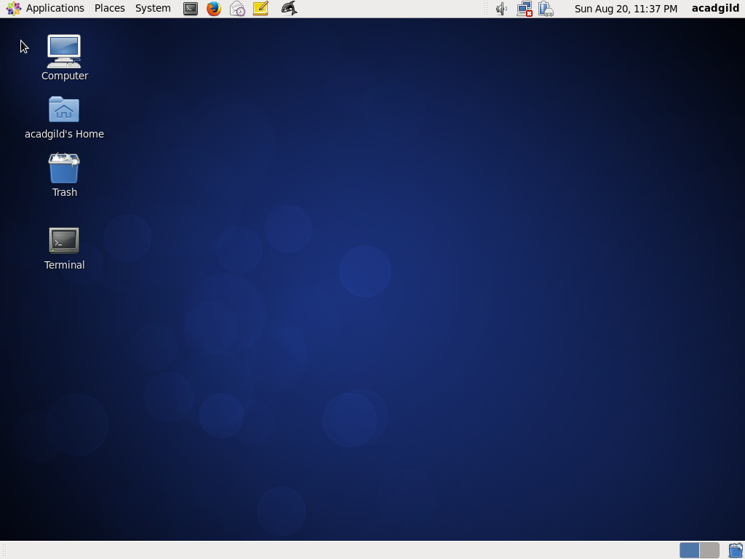

Terminal is also working fine. Below is the screenshot showing JPS command:

